**BIT STAFF QUARTERS PORTAL**

| **Name** | Nagasrivysnavi G |
| --- | --- |
| **Roll number** | 7376221EC234 |
| **Project ID** | 39 |
| **Seat number** | 359 |
| **Stack** | MERN Stack |

**STACK:**

| Front end | React.js |
| --- | --- |
| Back end | Node.js |
| Database | MongoDB |
| API | OpenAPI |

**PURPOSE:**

To provide a centralized and customized platform for managing various administrative tasks and facilities related to staff quarters in BIT. The portal aims to streamline processes, enhance efficiency, and improve service quality for staff members residing in the quarters.

**SCOPE:**

* Maintaining inmate and family member details
* Guest check-in and check-out form for pre-booked guests by inmates
* Complaint registration form for maintenance issues
* Faculty in and out details during holidays
* Utility fee calculation based on maintenance charges, electricity bills, water bills.

**USERS:**

**Faculty Members:**

Access:

Registered staff members will have individual accounts with login credentials.

Permissions:

They will have access to view their personal and family details, update

guest accommodations, register complaints, record their in and out movements,and view their utility fee details.

**Administrators:**

Access:

Administrators will have privileged accounts with administrative rights.

Permissions:

They will have full access to manage user accounts, oversee staff quarters operations, generate reports, perform analytics, and configure system settings.

**FEATURES:**

The system offers various features such as user registration, inmate and family member management, guest accommodation management, complaint registration, staff in and out recording,and utility fee calculation, reporting and analytics, security and data privacy, a user-friendly interface, scalability, integration with other systems, reliability and availability, performance optimization, accessibility, and documentation and support. It also ensures data privacy, protects user data, and provides a user-friendly interface for efficient navigation. The system also ensures high uptime, minimal downtime, and optimized performance for efficient user access.

**FUNCTIONAL REQUIREMENTS:**

* User login and authentication.
* Inmate and Family member details.
* Guest Check-in and Check-out details.
* Complaint registration and tracking.
* Staff In and Out recording.
* Utility fee calculation.
* Reporting and Analytics.

**NON-FUNCTIONAL REQUIREMENTS:**

* Security and data privacy.
* User-friendly interface.
* Scalability.
* Integration.
* Reliability and availability.
* Performance.
* Accessibility.
* Documentation and support.

**BUSINESS CONTEXT:**

BIT Staff Quarters Portal aims to centralise and automate various processes related to staff quarters management, improving efficiency and service delivery. The portal can help reduce manual paperwork, enhance communication, and provide a convenient platform for staff members to access relevant information and services.

**DEPENDENCIES:**

Adequate resources, including hardware, software, and development expertise, must be allocated for the project.

The portal's functionality relies on the availability and accuracy of data related to staff members, guests, maintenance, and financial information.

**USER STORIES:**

As an inmate, I want to see my personal and family details,pre-book guest accommodations to provide necessary information for a smooth check-in process, to register maintenance complaints through the portal and receive timely updates on the status of my complaints. to record my in and out movements during holidays to ensure the security and accountability of the quarters,to access information about maid availability and schedule services conveniently through the portal.

As an administrator, I want to manage user accounts, ensure data privacy and security, and provide technical support for the portal.

**FLOW DIAGRAM:**

**USER:**

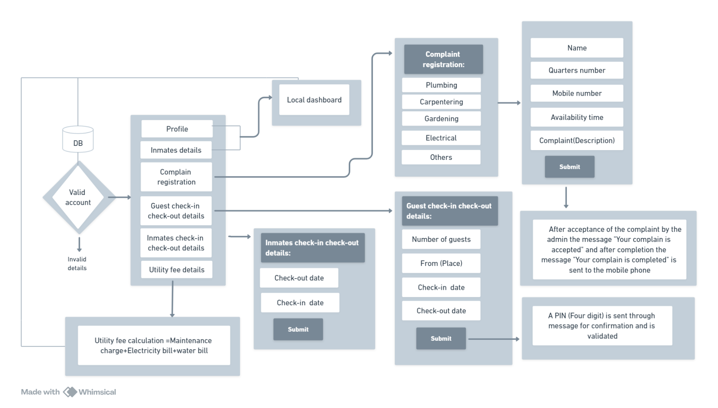

**ADMIN:**

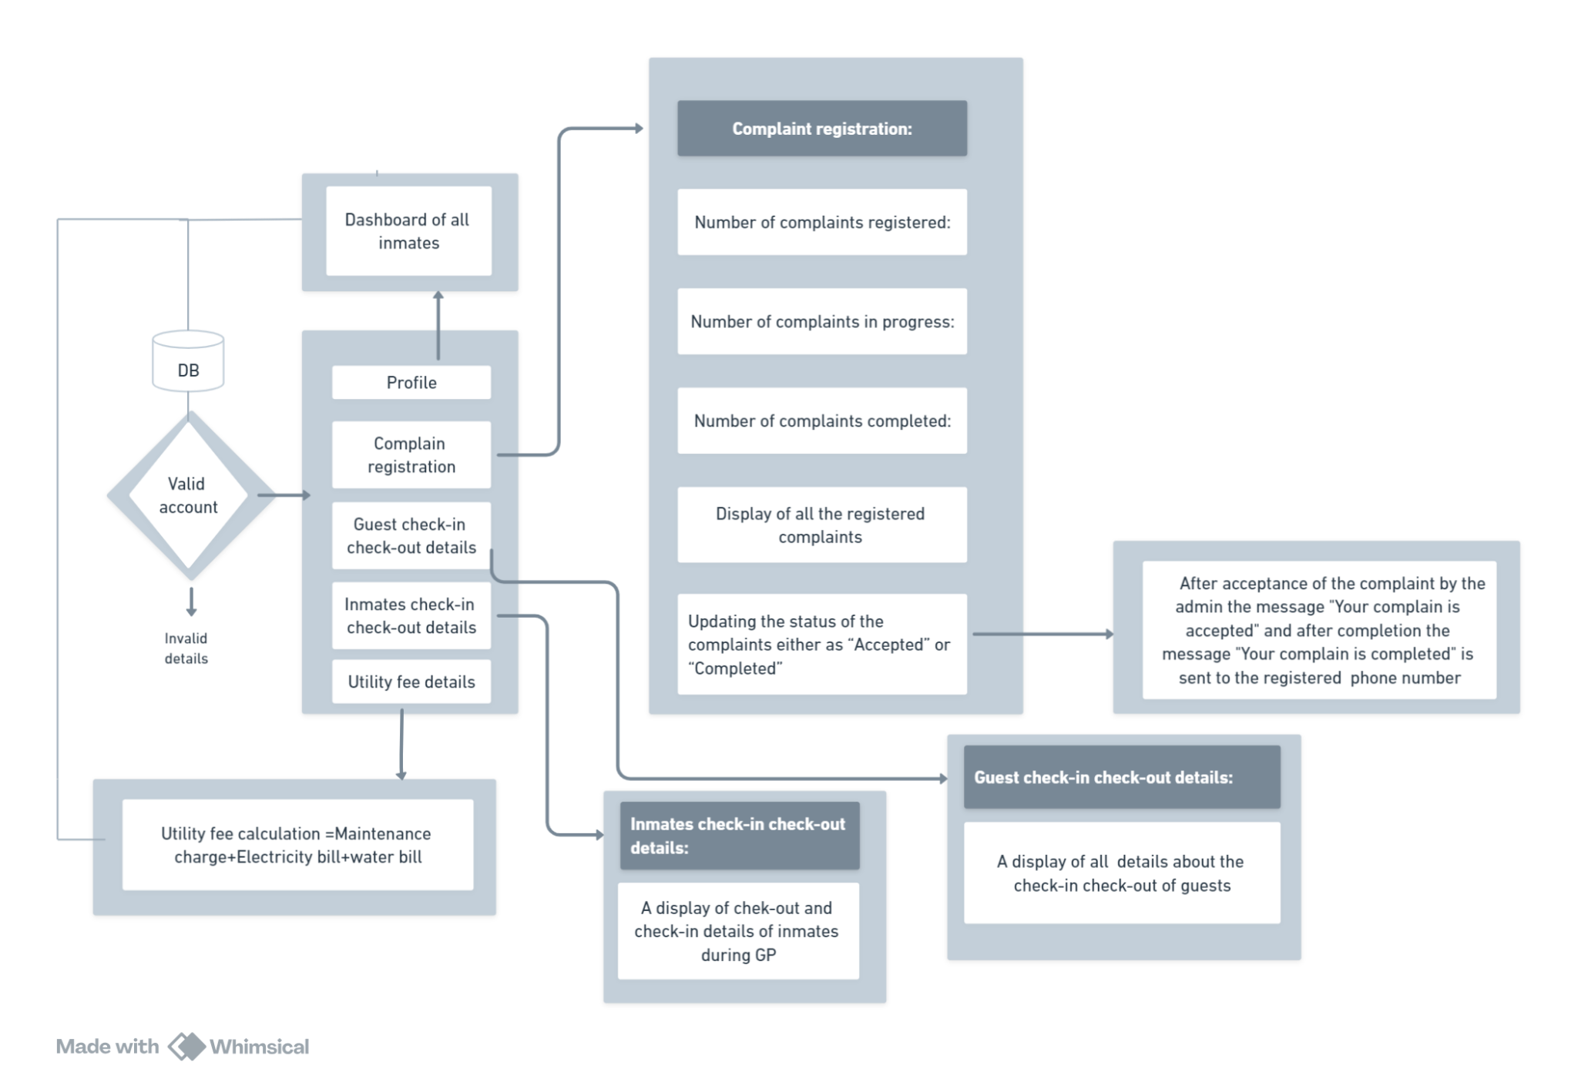

**ER DIAGRAM:**

